student | Ojuka Emmanuel boya | Reg. Number | MAY25/BCS/5479U
Team member | Kweyu Patrick | Field supervisor | OMARA INNOCENT
month | Month 1 | year | 1ST Year

Work space.
Folder What it holds
01 - Proposal | The project proposal and the supervisors confirmation
02 - Meeting Minutes | Minutes of every team meeting
03 - Communication plan | Our team communication plan
04 - Logbooks | Weekly and monthly logbooks
05 - website code | The HTML, CSS and JavaScript files of the project
06 - images and resources | Pictures and other material used by the project

Screen shots of the work

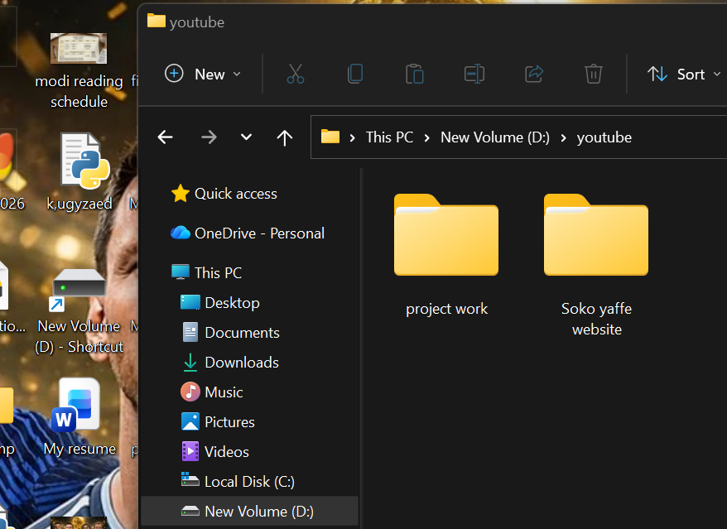
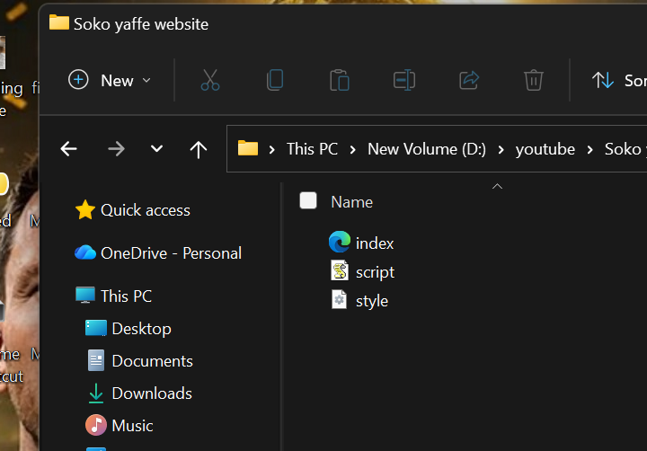
Folders that have the website files and project work files.
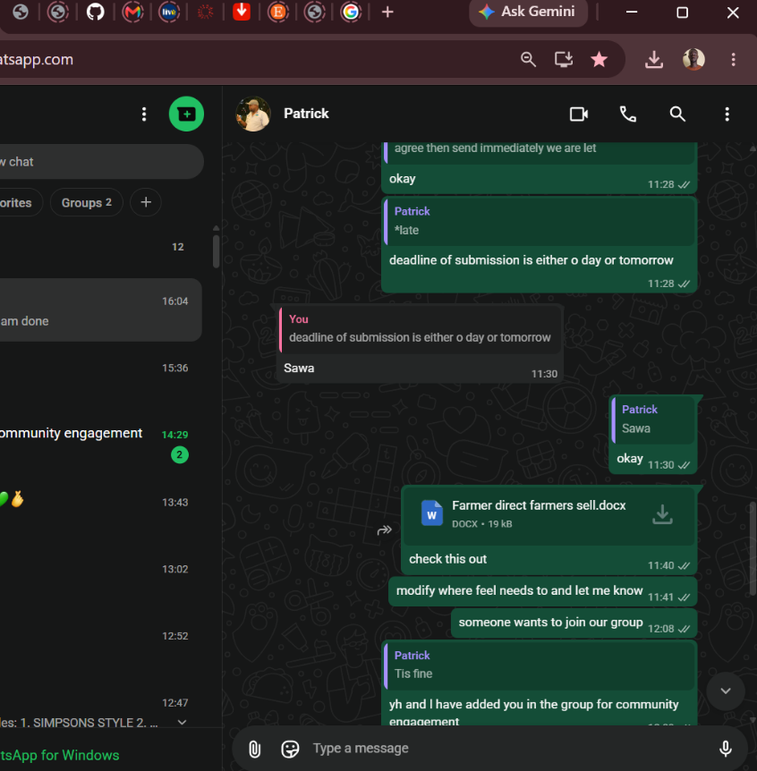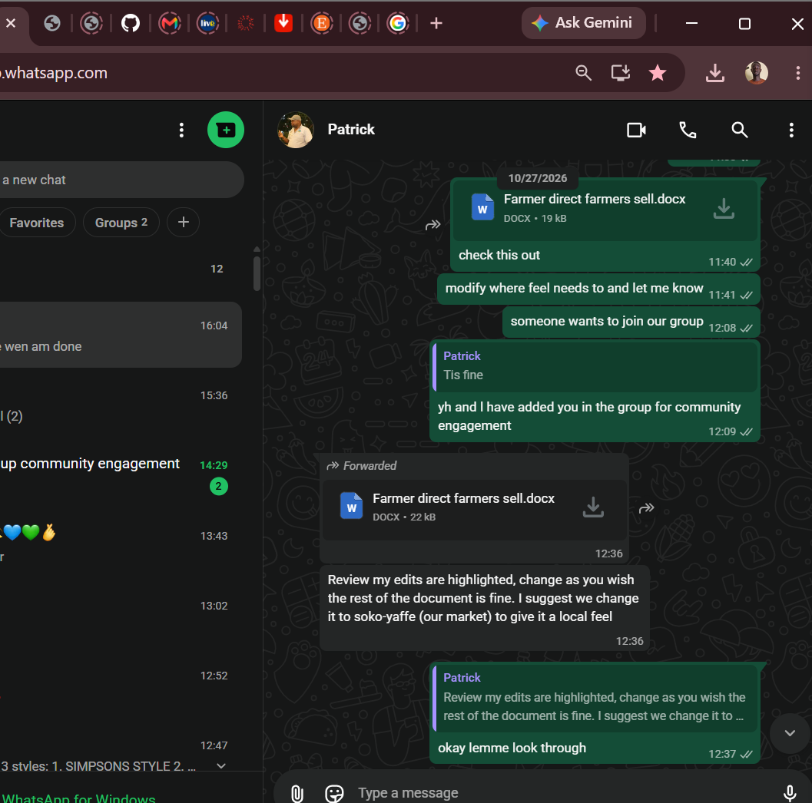

Screen shots of us sharing information of how to do the project better.
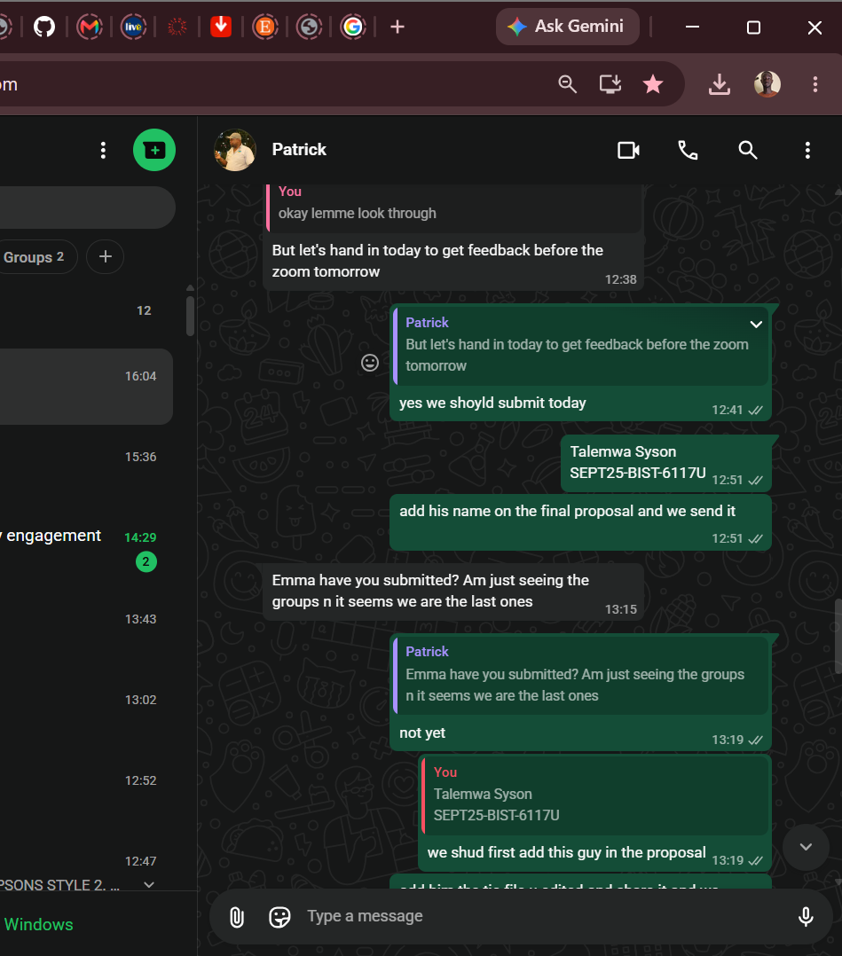

02. Meeting minutes
item | Details
Meeting date and time | Date: 27th / Oct / 2026 Time: 12:00noon – 2:00pm
participants | Ojuka Emmanuel Boya and Kweyu Patrick
Purpose of the meeting | To modify the project idea, assign each member a task, find the tools suitable for the project and discuss how to produce a good finished project.
Main issue discussed | How to make the project idea stronger and clearer.  Which tools suit the project: HTML, CSS and JavaScript.  How to share the work fairly between the two of us.  How to keep the work organised and make sure the finished project is useful and easy to use.
Decisions made | The final direction of the project was agreed.  HTML, CSS and JavaScript will be used to build the project.  Each member will research one tool and report back to the other.

Tasks assigned.
Task | Personal responsibility | deadline
Research HTML | Ojuka Emmanuel Boya | 7th / 11 / 2026
Research CSS | Kweyu Patrick | 7th/ 11 / 2026
Discuss ways of producing a good finished project | Both members | 13th / 11 / 2026

03. Team Communication Plan
What we communicate | How | How often
Daily updates and quick questions | WhatsApp message | Whenever needed
Team meetings | In person, or a WhatsApp call | At least once a week
Sharing project files | The shared project folder | Each time a file is updated
Contact with the supervisor | Email to Mr. Omara Innocent | When approval or feedback is needed
Recording decisions | Meeting minutes saved in the folder | After every meeting

04. Evidence of setting up the relevant tools.
Tools | What we use it for | Evidence
Shared project folder | Storing and sharing all project files | Screenshot in section 1
HTML, CSS and JavaScript | Building the structure, design and behaviour of the project | Screenshot below

Screenshot of the tools set up.

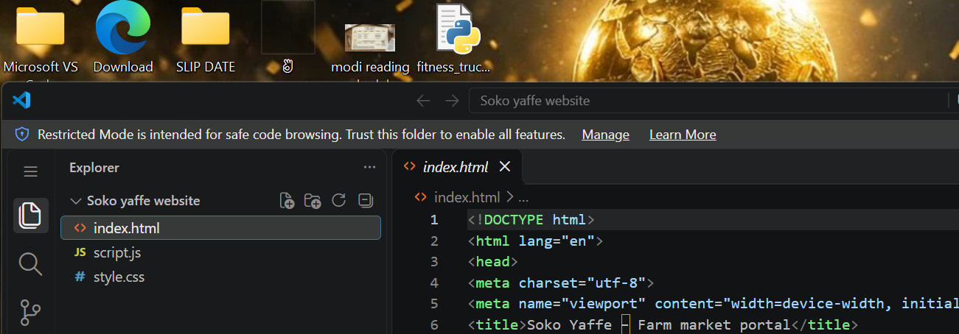5. Updated weekly logbook (Week 2)
Week 2 | Activity | Description
 | Modifying the project | We went back over our project idea and modified it to make it stronger and clearer. We looked at which parts needed improvement, adjusted them, and agreed on the final direction of the project before moving on.
 | Assigning members tasks | We assigned each member what to do so that the work is shared fairly. Ojuka Emmanuel Boya was given the task of researching HTML and Kweyu Patrick the task of researching CSS, and we agreed to discuss ways of coming up with a good finished project together. Each member was told what is expected of them.
 | Finding suitable tools | Members looked for the tools best suited to building our project. We settled on HTML for the structure of the website, CSS for its design and JavaScript for the parts that respond to the user. We considered what each tool can do, whether it is easy to learn and use, and whether it fits the project we chose, so that we can build without delays later.
 | Planning a good final project | We discussed ways of coming up with a good finished project. We talked about how to keep the work organised, how to test what we build, and how to make sure the final system is useful, accurate and easy to use.
 | Record keeping | We updated our logbooks with the work done during the week and wrote the minutes of our meeting, together with our team communication plan, a description of our organised workspace and evidence of the tools we set up.

Student signature: _____________ Field supervisor Approval: ____________

